Press Release
September 10, 2018

Reduced Cost, Higher Speed and Improved Usability with FOBA MarkUS Laser Marking Software Update

With the launch of its latest laser marking software version, MarkUS 2.12, FOBA introduces not only a range of advancements in vision-based laser marking, but also a great potential for cost-savings in direct part marking. The update’s major enhancement is the patent-pending full-field imaging technology “Mosaic” which enhances automated mark alignment and saves expenses by making product fixtures obsolete.

Selmsdorf, September 2018 – The new laser marking software release MarkUS 2.12 offers industries mainly in the fields of automotive part production and medical device marking numerous advantages for a cost and user-optimized laser marking workflow.

The most important new feature is “Mosaic”, a highly effective function which enables operators to place to-be-marked parts in any orientation within the marking field. Expensive fixtures are no longer needed and the mark will still be aligned perfectly.

Mosaic combines through-the-lens vision with the tiling of multiple images that are then stitched together to form a single image, covering the entire marking area. This simulates a virtually straight-down view, created by a miniature camera that is embedded inside the laser scan head.

The benefits of this novelty include significant time and cost savings by reducing setup and process operation efforts as well as the amount of scrap during the marking process. The fact that the implementation and maintenance of industrial fixtures is completely avoidable makes Mosaic a most economic feature.

The new MarkUS 2.12 software version additionally includes a Laser Parameter Expert that makes it easier and faster for operators to select the right marking parameters and achieve the required mark quality on specific materials. A selection of the most common marking methods and materials is built-in.

FOBA products are now also supported by an EtherCAT interface which improves the system’s interoperability in industrial environments.

A new lighting for the built-in camera addresses the challenges with imaging curved and shiny parts by programming pairs of light banks while allowing machine to machine performance reproducibility. The new lighting also improves the OCV (Optical Character Verification) and 2D code validation functionalities included in FOBA’s vision-based laser marking systems.

FOBA offers personal consultation to provide detailed information about the new software features. For an appointment with the FOBA sales team call +49 38823 55-556 or +1 630 694 3243 (for US customers) or e-mail to info@fobalaser.com

Alltec GmbH | FOBA Laser Marking + Engraving

www.fobalaser.com

Picture for editorial use:

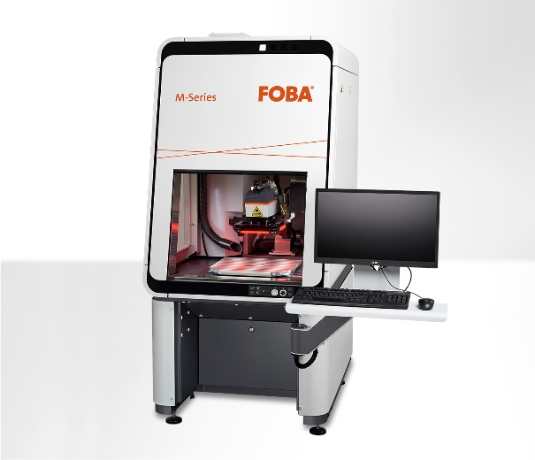

FOBA M2000 laser marking station with integrated MarkUS 2.12 software and new lighting.

For additional information and to forward reader responses please contact:
Susanne Glinz | Campaign Manager
ALLTEC GmbH | An der Trave 27 – 31 | 23923 Selmsdorf/ Deutschland
Tel.: +49 (0)38823 55-547 | Fax: +49 (0)38823 55-222
susanne.glinz@fobalaser.com | www.fobalaser.com

About FOBA www.fobalaser.com: FOBA Laser Marking + Engraving is among the leaders in manufacturing and supplying precision laser systems for marking and engraving. FOBA marking lasers mark a variety of materials and parts not least in the key markets of Automotive and Medical but also in Electronics, Plastics, Safety and ID. FOBA laser workstations for marking and engraving are especially applied in the fields of Automotive part production and Medical device marking as well as in Tool, Metal and Mold Making, Plastics processing and Jewelry. Worldwide sales and service branches service the most important markets.

