Media Release
October 26, 2022

Cool touch laser marking for delicate substrates: FOBA launches green laser

Selmsdorf/Wood Dale, October 2022 – FOBA has developed a 532 nanometers wavelength green laser marking system which offers new possibilities for industrial direct part marking. Supplemented by FOBA’s comprehensive marking workflow, the low heat laser applies perfect marks on materials with extraordinary absorption properties. Such materials include white, transparent, or red plastics as well as highly reflective metals. The green laser completes the range of laser wavelengths in FOBA’s portfolio of marking systems.

A significant increase in marking speed and marking quality on previously insufficiently markable materials are the main benefits of FOBA’s green laser. Affected materials include special plastics like UHMWPE, HDPE or PMMA for which additives might no longer be necessary, as well as glass or shiny substrates. Compared to other laser types like UV or fiber, the green laser shows better marking results while achieving superior marking speeds.

The application of the green laser marker can be facilitated using FOBA’s proven laser marking workflow with camera and mark alignment software. “The optical part inspection and validation of marked contents as well as the automated and precise positioning of the laser mark have long been valued by our customers as a reliable and safe workflow solution”, says Philipp Febel, director product management at FOBA. “Our green laser can easily be equipped with various laser alignment tools and works with any of the available FOBA user interfaces.”

The FOBA V.0071-gr and FOBA V.0141-gr green laser marking systems close the gap between UV (355 nm)- and fiber (1,064 nm)-laser markers. The combination of relatively high laser power and a vanadate source enables extended applicability and high speed. “Based on customer requirements, we have developed a leading- edge marking solution with to address the most challenging marking applications”, says Philipp Febel.

The new marking laser is available with either 7- or 14-watt laser power variations. It can flexibly be integrated into production environments due to a smaller marking unit (compared to the UV-laser), a broad range of available interfaces and five possible marking field sizes. The lifetime of FOBA’s green laser vanadate laser source is twice the lifetime of a UV laser source, which minimizes the total cost of ownership.

FOBA Laser Marking + Engraving
www.fobalaser.com/
Find the following and additional images for free download at: https://www.fobalaser.com/newsroom-events/news-press/cool-touch-laser-marking-for-delicate-substrates-foba-launches-green-laser/

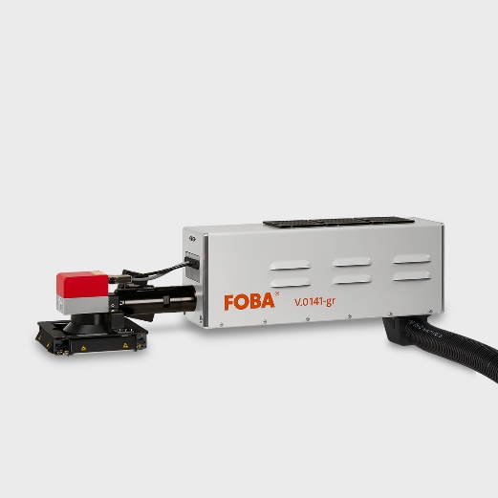
The green laser marking system FOBA Y.0141-gr is a 532 nm wavelength laser system with a vanadate source and 14-watt laser power. (Image rights: FOBA)
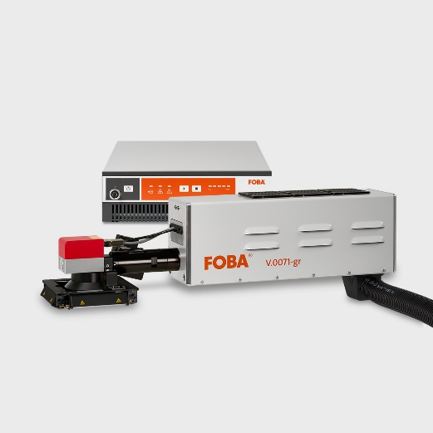
FOBA V.0071-gr 7-watt laser marking system is classified laser protection class 4 and must be equipped with a housing or integrated into a marking unit. (Image rights: FOBA)

For additional information and images for editorial use please contact:

Viola Kirk | Campaign Manager | FOBA Marketing Communications
ALLTEC Angewandte Laserlicht Technologie GmbH
An der Trave 27 – 31 | 23923 Selmsdorf
Tel.: +49 (0)38823 55-501
viola.kirk@foba.de | www.fobalaser.com

About FOBA www.fobalaser.com
FOBA Laser Marking + Engraving (brand of ALLTEC Angewandte Laserlicht Technologie GmbH) is one of the leading suppliers of advanced laser marking systems. FOBA develops and manufactures marking lasers for integration as well as laser marking workstations with vision assisted marking workflows. FOBA technology is being applied for the direct part marking of any kind of metals, plastics, or other materials in industries like automotive, medical, electronics, plastics or tool, metal and mold making. With its worldwide sales and service branches and its headquarters near Lübeck/Hamburg (Germany) ALLTEC/FOBA is part of the Danaher Corporation.

