Media release
June 27, 2023

USP laser marker of the latest generation: FOBA is coming to the market with an ultrashort pulse laser

Selmsdorf, June 2023 – FOBA’s new F.0100-ir marking system creates deep black markings on medical stainless steel, titanium, or plastics. Its adjustable pulse width and its 10 watts laser power enable accurate results on various surfaces. In combination with FOBA's validation-ready process solution, the F.0100-ir provides advantages especially for medical device manufacturers.

The ultrashort pulse laser marks in the deepest, matt and non-reflective black without generating significant heat input on the workpiece. Even through further processing steps, such as passivation, the marking remains reliably legible and corrosion resistant. Due to the very short pulses down to the femtosecond range, in combination with high pulse energies, the system marks various stainless steels, titanium and a variety of plastics.

When developing its ultrashort pulse laser system, FOBA placed particular emphasis on its ability to be integrated into the proven FOBA workflow. "For our customers, it is of course crucial that our lasers achieve consistently reliable marking results. But they also trust that the entire process is highly dependable, and a new marking system has to keep up with that," says FOBA's Director Product Management Philipp Febel.

The integration of a capable, compact and very flexible laser source was the top priority during product development. "Our laser system offers adjustable pulse widths for specific material requirements. This is not a matter of course in the ultrashort range," says Philipp Febel. As a result, the FOBA F.0100-ir marking system provides a wide range of applicability, high precision, and outstanding process stability.

"The laser head is so compact that we can integrate it into our M-Series marking workstations. And that is often a requirement with our customers," Febel explains further. Since the system is air-cooled and uses hardly any consumables, it requires little maintenance. In addition, the high marking speed in combination with FOBA's established camera and software solutions enable lean and efficient part manufacturing.

FOBA offers interested users sample markings with the new USP marking system. Marking applications from medical device manufacturing, automotive component production or electronics are suitable. Materials that are usually marked with other wavelengths such as UV can also be considered. Detailed advice on the best possible marking configuration will be part of the service.

FOBA Laser Marking + Engraving
https://www.fobalaser.com/

Images for editorial use:

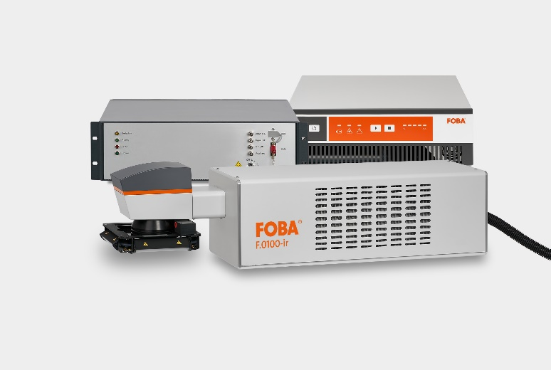
FOBA F.0100-ir ultrashort pulse laser marking system with its laser control and supply units.

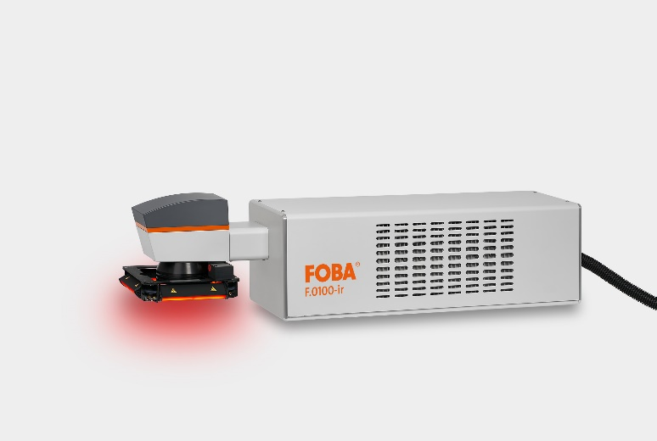
FOBA F.0100-ir is the latest generation of FOBA’s laser marking systems which incorporates an ultrashort pulse laser source.

For additional information and images please contact:

Susanne Glinz | Campaign Manager Marketing Communications
ALLTEC Angewandte Laserlicht Technologie GmbH
An der Trave 27 – 31 | 23923 Selmsdorf/Germany
Tel.: +49 (0)38823 55-547
susanne.glinz@fobalaser.com | www.fobalaser.com

About FOBA www.fobalaser.com
FOBA Laser Marking + Engraving (brand of ALLTEC Angewandte Laserlicht Technologie GmbH) is one of the leading suppliers of advanced laser marking systems. FOBA develops and manufactures marking lasers for integration as well as laser marking workstations with vision assisted marking workflows. FOBA technology is being applied for the direct part marking of any kind of metals, plastics, or other materials in industries like automotive, medical, electronics, plastics or tool, metal and mold making. With its worldwide sales and service branches and its headquarters near Lübeck/Hamburg (Germany) ALLTEC/FOBA is part of the Danaher Corporation.

