Media Release
January 15, 2024

Ultra black laser marking for medical technology: FOBA presents new product at MD&M West

Selmsdorf, January 2024 – US-Product premiere at the trade show: FOBA Laser Marking + Engraving presents its ultrashort pulse laser for ultra-black laser marking for the first time in the United States at MD&M West (Anaheim, CA, February 6-8, 2024).

"After the successful premiere in Europe, we are proud to present our new product to our customers in the USA for the first time. The FOBA ultrashort pulse laser produces deep black markings that are particularly gentle on materials, making it a real asset for the medical technology market in particular," reports Philipp Febel, Head of Product Management at FOBA. Visitors of the trade fair can see the laser marking quality directly on site at the German Pavilion at booth 3157.

The ultrashort pulse laser F.0100-ir marks in the deepest, matte and non-reflective black without generating significant heat input on the workpiece. Even through further processing steps, such as passivation, the marking remains reliably legible and corrosion resistant. Due to the very short pulses down to the femtosecond range, in combination with high pulse energies, the system marks various stainless steels, titanium and a variety of plastics. The laser is so compact, that it can be integrated into FOBA’s M-Series and will be shown at the trade fair in an M2000 workstation.

"We want to actively support our customers with the current and upcoming UDI labeling standards," says Jeffrey A Kniptash, Sales Manager Americas at FOBA. According to FDA regulations, all reusable and reprocessed medical devices must bear a directly marked UDI (Unique Device Identification), meaning a unique numeric or alphanumeric code. "We offer expert advice on this topic, and thus facilitate the implementation and validation of a secure laser marking process," continues Jeffrey A Kniptash.

Individual appointments for a demonstration at the FOBA booth can be requested at info@fobalaser.com

FOBA Laser Marking + Engraving
https://www.fobalaser.com/

Application Center / Service Center
1500 N Mittel Blvd.
Wood Dale, IL 60191-1072, USA
Sales Support T +1 630 694 3243
Further Information:
MD&M West 2024
February 6-8, 2024 | Anaheim Convention Center | Anaheim, CA
https://www.imengineeringwest.com/en/show/show-brands/mdm-west.html

German Pavilion
https://mdmwest.german-pavilion.com/en/sites

Find the following and additional images for free download at:
https://www.fobalaser.com/newsroom-events/news-press/foba-presents-new-ultrashort-pulse-laser-at-mdm-west/

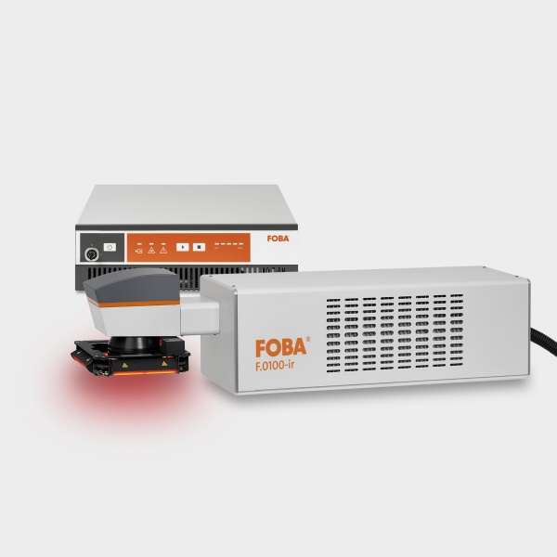
The FOBA ultrashort pulse laser F.0100-ir for deep black, material-protecting markings (Copyright: OBA)

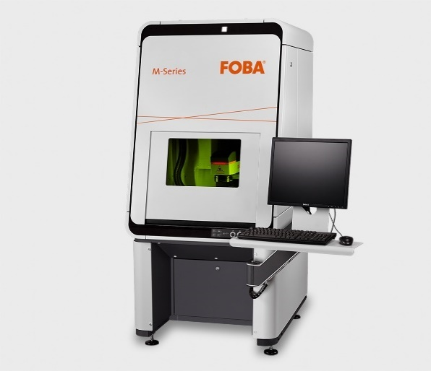

The FOBA M2000 marking workstation is classified in laser protection class 1 and is optionally equipped with the Mosaic marking function. (Copyright: FOBA)

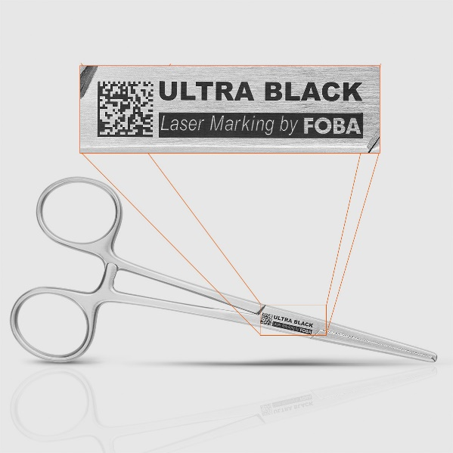
Ultrashort laser marked stainless steel clamp with machine readable UDI code and clearly legible characters. (Copyright: FOBA)

For additional information and images for editorial use please contact:

Kathrin Urban | Campaign & Event Manager
ALLTEC Angewandte Laserlicht Technologie GmbH | FOBA Laser Marking + Engraving
An der Trave 27 – 31 | 23923 Selmsdorf
Tel.: +49 (0)38823 55-440
kathrin.urban@fobalaser.com | www.fobalaser.com

About FOBA www.fobalaser.com
FOBA Laser Marking + Engraving (brand of ALLTEC Angewandte Laserlicht Technologie GmbH) is one of the leading suppliers of advanced laser marking systems. FOBA develops and manufactures marking lasers for integration as well as laser marking workstations with vision assisted marking workflows. FOBA technology is being applied for the direct part marking of any kind of metals, plastics, or other materials in industries like automotive, medical, electronics, plastics or tool, metal and mold making. With its worldwide sales and service branches and its headquarters near Lübeck/Hamburg (Germany) ALLTEC/FOBA is part of the Veralto Corporation.

